Class 3 work – w/c 18th May 2020
Hi. I hope you are still all keeping safe. This is the final week of this half term. Thank you for continuing to send through the work you are completing at home. It is great to see and helps the children keep in touch with school and vice versa. It is not always easy and if there are some days that you are finding that your child struggles to focus on school work then please do not worry. The most important thing is to keep staying safe and well.
Please email all completed work directly to me at the following address:
Jayne.fenton@grangemoorps.co.uk
I would really like to see the completed Topic and Science work please.

- Maths (work to be completed by Friday 22nd May)
Year 5 and 6
This week we will be recapping factors, primes, multiples, square and cube numbers. BBC Bitesize has some useful links for factors, multiples and primes at the address below:
https://www.bbc.co.uk/bitesize/topics/zfq7hyc
Multiples and Factors - Please complete the BBC Bitesize daily lesson and the associated worksheet at:
https://www.bbc.co.uk/bitesize/articles/zfchpg8
Prime numbers and square numbers - Then do the following BBC Bitesize daily lesson and associated worksheet at:
https://www.bbc.co.uk/bitesize/articles/zvv6t39
Year 5:
Complete the following My Maths work:
- Squares and cubes
- Highest Common Factor
Year 6:
Complete pages 14-18 in your SAT buster book “Number, Ratio and Algebra”
Tegan – See worksheets on addition and subtraction

- English/SPAG
Written work will be covered under “Topic” and “Science” this and next week.
Spelling:
“Spot Mr Whoops’ Mistakes” – activity to revisit spellings from the last 6 weeks appropriate for the spellings you have been doing.
SPAG:
Year 5 - Complete the BBC Bitewise daily lesson on Using similes and metaphors.
https://www.bbc.co.uk/bitesize/articles/z4nybdm
Year 6 – Complete the BBC Bitewise lesson on Using Hyperbole, similes and metaphors
https://www.bbc.co.uk/bitesize/articles/zhcc92p

- Topic – Rivers

This project work is to be completed over 2 weeks and includes elements of research, written work and presentation.
I would like you to find out as much as you can about the River Severn which is the longest river in the UK. This includes some of the towns/cities it flows through, its length, some of its features, why it was important in the past and why it is still important today. What type of things are rivers used for nowadays? I then want you to choose another river from somewhere else in the world and complete the same research. I would suggest one of the following: Amazon, Nile, Ganges, Yangtze, Mississippi, Rhine. The following website is a good starting point:

http://www.primaryhomeworkhelp.co.uk/rivers.html

You can present your findings in whichever way you like but please send through to me so I can take a look.

- Science/DT

This project work is to be completed over the next 2 weeks. What makes a sail boat move and what forces are acting upon it? I would like you to design a boat and write out instructions on how to make your boat that could be followed by someone else. Remember to include what you will need including equipment as well as materials and write your instructions in clear steps. Diagrams/drawings could be useful too. I then want you to try and see if your boat will float (you can use a sink or your bath!!) and whether you can propel it along using some form of wind power. Draw a diagram of this to show what happens and which forces are acting on your boat.
I look forward to seeing your boats in action!

- Art – Rivers and Coasts
Draw, paint, colour or collage a river or a coastal scene. I look forward to seeing your creations

- PHSE
This week is Mental Health Awareness Week with the theme of kindness. Try and perform at least 2 acts of kindness this week. Maybe you could make a cup of tea for your mum and dad, write a letter to someone who may be on their own and lonely or give them a call. See attached sheet.

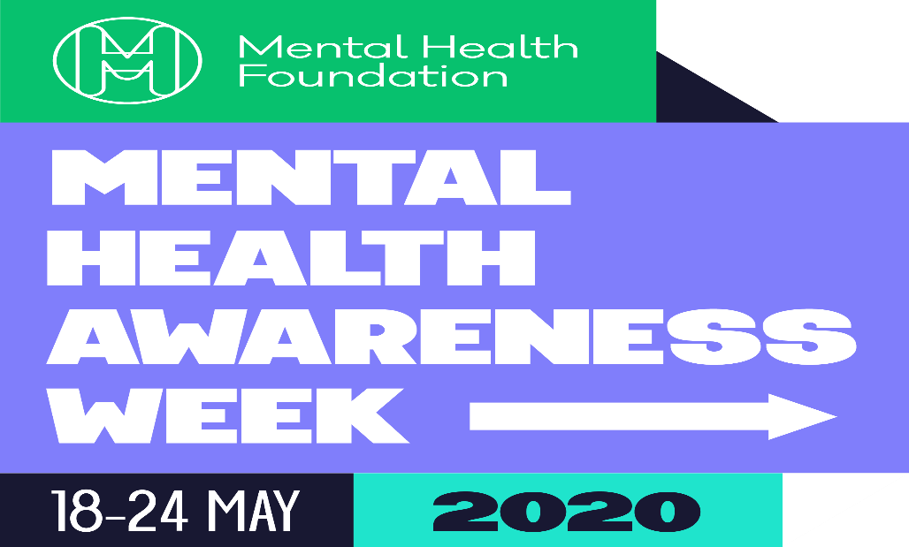

This week it will be Mental Health Awareness Week and the theme is ‘kindness’. We would love to hear about any acts of kindness that you have been involved in.
As a special challenge for this week, we would like to see and hear about ‘random acts of kindness’ that you have done. These could be for someone in your home or even in the local community. Take pictures and share them with us. You could make someone smile with the smallest of gestures, for example, make a card, bake some biscuits, write a letter or help someone.
(Please remember to stay safe and observe the rules of social distancing).

If you would like more information about mental health and well-being there are many websites where you can access support and advice
https://www.mentalhealth.org.uk/your-mental-health
https://www.mind.org.uk/information-support/for-children-and-young-people/coronavirus/coronavirus-and-your-wellbeing/

Take care, have fun and make someone smile. We cannot wait to see what you do!
Best wishes from all the staff

Work completed w/c 18th May 2020

 | MyMaths/Booklets | SPAG | Topic | Science/DT/English
 |  | Similes and metaphors | Comparing rivers | Design boat an instructions
Year 6
Nihar Christison
Charlie Eccles
Florence Jones
Fara Mediwake
Chloe Morton
Boe Speight
Tegan Wetherhall
Tilly Wrightson
Year 5
Kian Britton
Ruby Brook
Harry Ellis
Violet Flynn
Ashton Gibson
Laila Heaton
Lucas Lyles
Amina Pyke
Hollie Sharpe
Aali Spencer
Lewis Smith
Indie Toth
Lily Wake
Kayla Wetherhall
Arron Wood
Laila Wynn

