

**Sycamore**

**A Ticket to Kalamazoo!**

**Croaky: Search for the**

**50 Recommended Reads for...**

**Marge in Charge**

Isla Fisher & Eglantine Ceulemans

**The Eyebrows of Doom**

Steve Smallman & Miguel Ordonez

**Martin’s Mice**

Dick King Smith

**The Mellons Build an Eco-House**

Robin Jacobs & Nik Neves

**The Midnight Panther**

James Carter & Neal Layton **Sasquatch**

Matty Long

**Marv and the Mega Robot**

Alex Falase-Koya & Paula Bowles

**Meet the Microbes!**

Dr Emily Grossman & Maggie Li

Poonam Mistry

**The Naughtiest Unicorn**

**A Way to the Stars**

David Almond & Gill Smith

**Daisy and the Trouble with London**

Kes Gray

Pip Bird & David O'Connell

**The Panda’s Child**

**Aaron Slater, Illustrator**

**Michael Rosen’s Book of Very Silly Poems**

Which ones

have you read?

Andrea Beaty & David Roberts



# Amy Gets Eaten

Adam Kay & Henry Paker



# An Alien in the Jam Factory

Chrissie Sains & Jenny Taylor



# An Emotional Menagerie

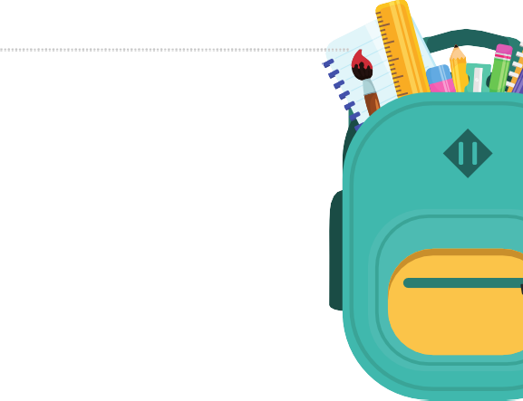

**Flat Stanley**

Jeremy Strong & Jamie Smith

The School of Life

Jo Empson

**The Tunnel**

Jeff Brown & Rob Biddulph

**Night Flight**

**Blanksy the Street Cat**

Gavin Puckett & Allen Fatimaharan

Anthony Browne

**George’s Marvellous Medicine**

Roald Dahl & Quentin Blake

Katie Cottle

**Bumble & Snug and the Angry Pirates**

Mark Bradley

**Penguin Huddle**

Ross Montgomery & Sarah Warburton

**Traction Man is Here**

Mini Grey

**Inside the Villains**

**The Big Book of the Blue**

Clotilde Perrin

**Can I Build Another Me?**

Yuval Zommer

**Troll Stinks!**

Jeanne Willis & Tony Ross

**InvestiGators**

Shinsuke Yoshitake

**The Couch Potato**

John Patrick Green

**Claude at the Circus**

Jory John & Pete Oswald

**We All Celebrate!**

Chitra Soundar & Jenny Bloomfield

Alex T. Smith

**Counting on Katherine**

Helaine Becker & Dow Phumiruk

**Izzy the Inventor and the Unexpected Unicorn** Zanna Davidson &

Elissa Elwick

**Magic Faces: Heroes of the Pirate Ship**

Esi Merleh & Abeeha Tariq

**The Emerald Forest**

Catherine Ward & Karin Littlewood

**Wheels**

Tom Schamp

**The Enchanted Wood**

Enid Blyton

**You Must Bring a Hat**

Simon Philip & Kate Hindley

[SCAN ME](https://www.booksfortopics.com/year-2/)

**For children in Year two these are books to share with an adult**



# Darwin's Super-Pooping Worm Spectacular

Polly Owen & Gwen Milward



# Einstein the Penguin

Iona Rangeley & David Tazzyman



# Emperor of the Ice

Nicola Davies & Catherine Rayner



Michael Rosen & Shoo Rayner

**Milo’s Monster** Tom Percival **Mooncat and Me** Lydia Corry

# Nellie Choc-Ice, Penguin Explorer

Jackie Morris & Cathy Fisher



# The Proudest Blue

Ibtihaj Muhammad,

S.K Ali & Hatem Aly



# The Rainbow Bear

Michael Morpurgo & Michael Foreman



# The River That Flows Beside Me

Charlotte Guillain &