
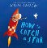
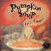
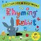
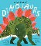
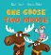
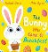
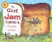
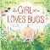
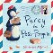
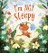
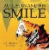
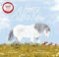
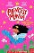

A First Book of
50 Recommended Reads for...
One Goose, Two Moose Kael Tudor & Nicola Slater Percy the Post Penguin
Genevieve Aspinall
Dinosaurs
Simon Mole & Matt Hunt
How to Catch a Star
Oliver Jeffers
Princess Minna: The Enchanted Forest
Kirsty Applebaum & Sahar Haghgoo
Pumpkin Soup
The Bunny Who Came to Breakfast
Rachael Davis & Mike Byrne
The Giant Jam Sandwich
Janet Burroway & John Vernon Lord
The Girl Who Loves Bugs
Lily Murray & Jenny Løvlie
A Horse Called Now
Ruth Doyle & Alexandra Finkeldey
I’m Not Sleepy
Helen Cooper
The Rhyming Rabbit
Julia Donaldson & Lydia Monks
Raahat Kaduji
Augustus and His Smile
Jabari Tries
Catherine Rayner
Gaia Cornwall
Blue Monster Wants it All!
Listening to the Quiet
Rubbish? Don’t Throw It Away!
Linda Newbery & Katie Rewse
Snail in Space
Rachel Bright & Nadia Shireen
There’s a Tiger on the Train
Mariesa Dulak & Rebecca Cobb
This is the Ship that Jack Built
Peter Millett & Sam Caldwell
50 Recommended Bedtime Story Books Reads for Apple Class

Share with an Adult

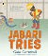
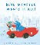
Jeanne Willis & Jenni Desmond

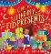
Can You Find My Eid Presents?
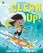
A. M. Dassu & Junissa Bianda

Clean Up!

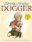
Nathan Bryon & Dapo Adeola

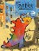
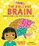
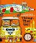
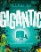
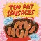
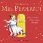
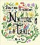
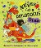
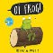
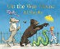
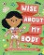
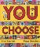
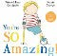
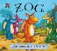
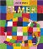
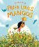
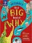
Dogger
Shirley Hughes
Nabil Steals a Penguin
Nishani Reed & Junissa Bianda
Tad
Elmer
Benji Davies
William Bee’s Wonderful World of Things That Go!
William Bee
Nature Trail
David McKee Benjamin Zephaniah &
Nila Aye
Farah Loves Mangos
Ten Fat Sausages
Michelle Robinson & Tor Freeman
Wise About My Body
Libby Walden & Ekaterina Trukhan
Sarthak Sinha

First Big Book of Why
Sally Symes, Stephanie Drimmer & Kate Slater
Never Let a Diplodocus Draw
Rashmi Sirdeshpande & Diane Ewen
Oi Frog!
The Amazing Mrs Pepperpot
Alf Proysen & Hilda Offen
You Choose
Pippa Goodhart & Nick Sharratt
The Artist
Kes Gray & Jim Field
Gigantic
Ed Vere
On the Way Home
Rob Biddulph
Jill Murphy
The Brilliant Brain
Dr Roopa Farooki & Viola Wang
You’re So Amazing
James Catchpole, Lucy Catchpole & Karen George
Zog
Julia Donaldson & Axel Scheffler

Cassie Silva & Frances Ives

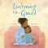
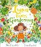
Luna Loves Gardening
Joseph Coelho & Fiona Lumbers

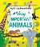
My encyclopedia of very important animals
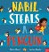
DK

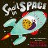
Super Duper You

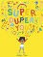
Sophy Henn

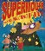
Supermouse and the Volcano of Doom
M. N. Tahl & Mark Chambers

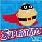
Supertato

Sue Hendra & Paul Linnet

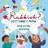
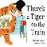
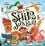
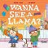
Wanna See a Llama?

Simon Philip & Ian Smith
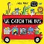
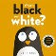
We Catch the Bus

Katie Abey
What is Black and White?
John Kane

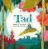
Books To

